a) row reduce this system by hand to find the exact solution

-..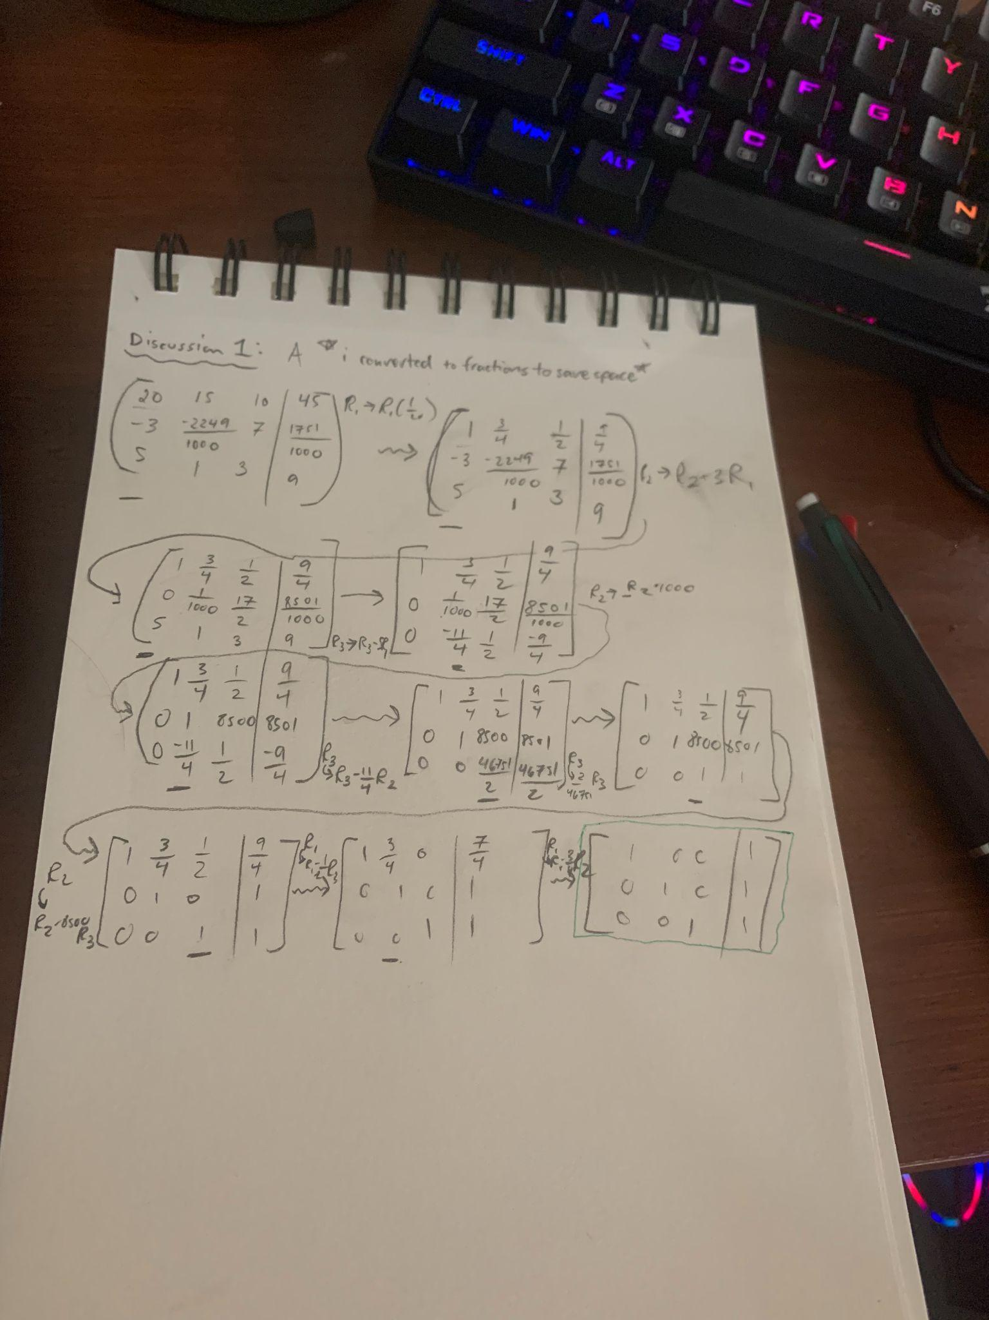

b) row reduce this matrix using only **5** significant digits, where the 6th significant digit and beyond is "*chopped*" (that is, truncate after 5 sig digs -- do not round.)

-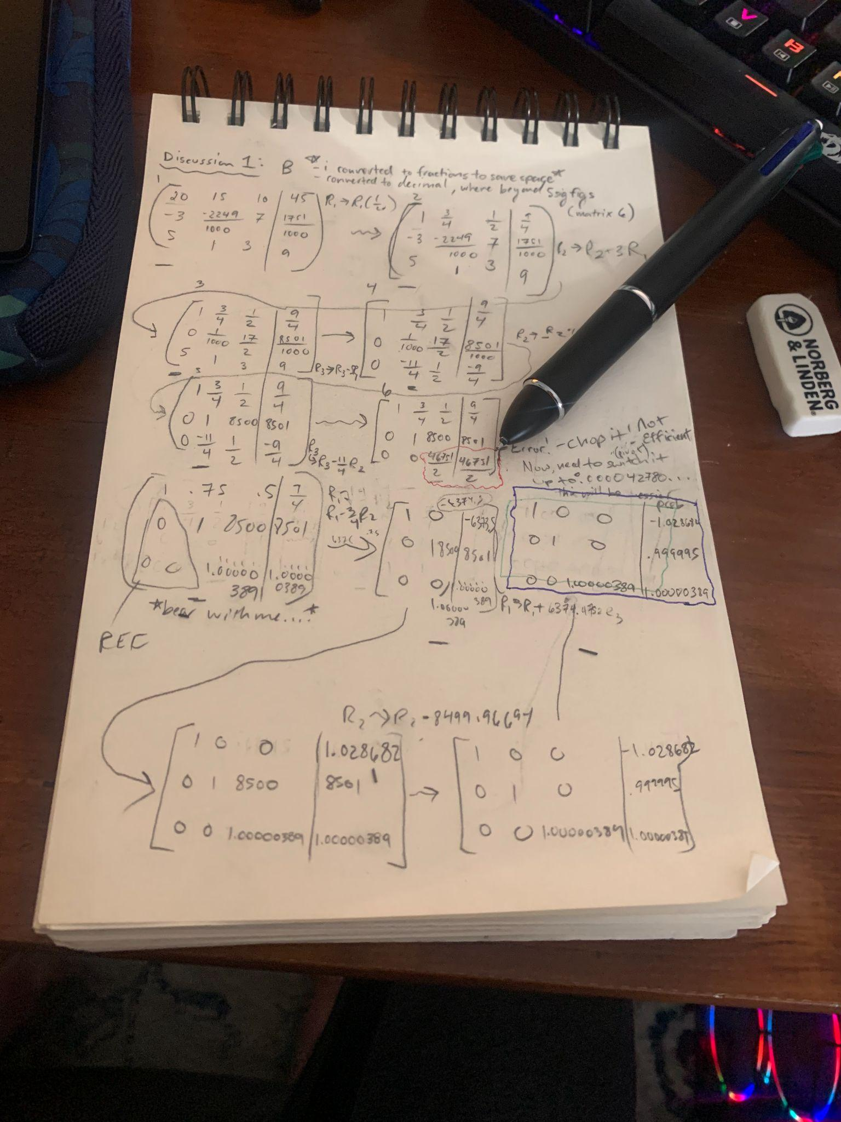

c) compare your two solutions.

-a) This is ideal and yields an optimal solution, with nice clean 1s and 0s in a matrix. Very precise.

-b) Perhaps you may not always have the time to evaluate all the decimals of a matrix, and speed is your priority. this is what has to happen in example b, where the extra digits were *chopped*! Equating this to real life, this is what happens: glance quickly over things without evaluating in depth & miss the digits.

*precision vs speed*

d) what are other challenges of representing matrices in a computer?

-limitations to data points. There may be scenarios where the computer does not evaluate the full big picture, and “truncates” part of the matrix, or data.

-This can be misinformative, and have serious repercussions, as shown in the example above. Such a minor recalculation sets off the rest of the matrix, and I imagine there will be variation in our b answers. It is harder to predict data at the individual level: Black swan?